SAB Project Manager Manual

# Table of Contents

1. Intro
2. Admin Usage
   1. Creating and Saving a Project
   2. Normal View vs Admin View
   3. Creating Resources
   4. Creating and Editing Tasks
   5. Task Status (Admin View)
   6. Task Notes
   7. Exporting to Excel
3. Normal Usage
   1. Opening and Saving a Project
   2. Task Status (Normal View)
   3. Task Notes

# Intro

This manual will go over the usage of the SAB Project Manager program. It is split into two parts, a manual for administrative purposes and a manual for a typical user. This program was made by Yusheng Hou, Keshav Santhanam, and Brian Truong for use by the Student Aircraft Builders.

# Admin Usage

# Creating and Saving a Project

The first thing you must do is create a new project. If you fail to create a new project, certain important files will not be created and functionality will be extremely limited. When creating a new project, you will first be asked for a password, and then you will choose a location and name for the project folder. The contact info (for when a part is marked broken) is hardcoded, but can be changed by opening the contact info file in notepad.

When you create a new project, a project folder will be created (with the name you provide) that contains the project file and the backup folder. The project file will be named the same as the project folder.

The project file is the file that stores everything except for password and contact info. The password is stored in a file called “misc.dat” and the contact info is stored in a file called “contact.dat”. These two files are placed in the backup folder. These files can be edited with any text editor (notepad). There is no way to change the files through the program.

The backup folder is identified by being the exact same name as the project file except with a “-Backup” appended to the end. If this backup folder is not found, the program will not be able to check the password at all, and thus never enter Admin View. The contact info will simply default to the hardcoded value.

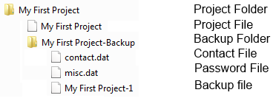

In addition, every time the program tries to save, it will also look for the backup folder and save a backup project file. This is equivalent to a normal project file in every way except its name has an ever increasing number appended at the end of it. If no backup folder is found, it will not save a backup file.

|  |  |  |
| --- | --- | --- |
|  | New… | Create a new project (will save the current project first) |
| Open… | Open a project file (will save the current project first) |
| Save | Save the current project to the last saved location |
| Save As… | Save the current project to a new project file |
| Export… | Export the current project to an Excel Sheet |
| Quit | Save the project if necessary and then quit |

Any save operation will attempt to make a backup in the backup folder if it exists. Hitting the X button on the window is equivalent to the Quit menu item.

Additionally, this program will not automatically save every period of time. Instead, it will save whenever the program is closed normally or when a new project is opened.

# Normal View vs Admin View

Normal View is the initial view the program starts in. To access Admin View, go to the View menu and click on the Admin View menu item. It will prompt for a password. If the password file cannot be found, you will not be able to enter Admin View. To fix this, either create the password file as defined in the previous section, or make a new project and replace the new project’s project file with your original project file.

In Admin View you have access to the following administrative features:

* Resource Panel
  + Creating and removing tools and parts
  + Mark parts and tools as broken
* Editing a task
* Creating a new task
* Undo-completing a task

For most of the following steps, you will need to be in Admin View.

# Creating Resources

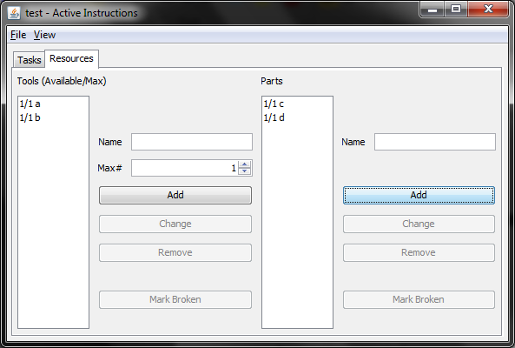

Using the Resource Panel, you can create resources. Simply type in the name of the resource, how many there will be, and click on the Add button. You cannot have two resources with the same name. You can rename a resource by selecting it from the list, typing in the new name, typing in the new number, and clicking the Change button. You can remove a resource by selecting it from the list and clicking on the Remove button. You cannot rename or remove a resource that is required some task.

When you click on the Mark Broken button, the program will first check if any affected tasks are being worked on. If so, it will prompt whether you want to continue and set those tasks to the Paused state. If you agree, you will then be prompted as to whether the correct people have been contacted. This will read the text from the contact file (as described earlier). If it cannot read the file for whatever reason, it will default to the hardcoded text. You can fix this by providing a contact file as detailed earlier.

Afterwards, it will ask for Foreman and Builder Names, then the related Task, and then a generic textbox for typing whatever else needs to be reported. This Broken Part report cannot be viewed within the program, but can be viewed in the exported Excel sheet.

# Creating and Editing Tasks

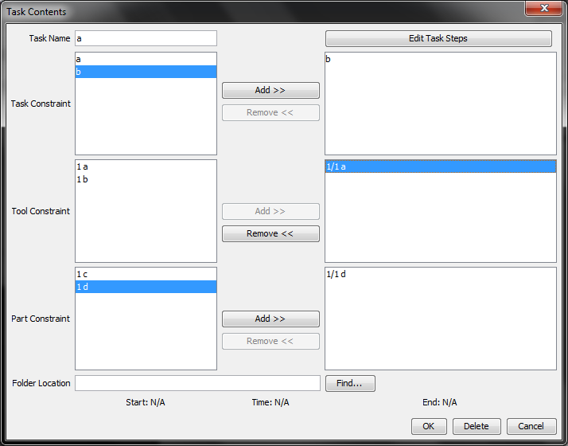

Creating a new task is as easy as clicking on the Create Task button on the right of the Task panel. Be sure you have Admin View enabled. Editing a task is similar except you click the Edit button on the task you want to edit.

Click on one or multiple constraints and the click on the Add button to add them. You can do the opposite by selecting constraints on the right side and clicking the Remove button.

You can edit the Task Steps by clicking on the appropriate button at the top right. You can select a folder/file to be associated with this task by clicking on the Find button at the bottom.

You can check when a task was started/completed and how much time has been spent at the bottom as well.

Finally, press the OK button when done to save the changes. You can also choose to delete the task instead if you are editing a task.

If a task is currently being worked on, you cannot delete the task or change the constraints. Pause the task first if you wish to change these things.

# Task Status (Admin View)

This section deals with possible Task Statuses when in Admin View. At any point, mouse over a status icon or button to display a tooltip describing its meaning.

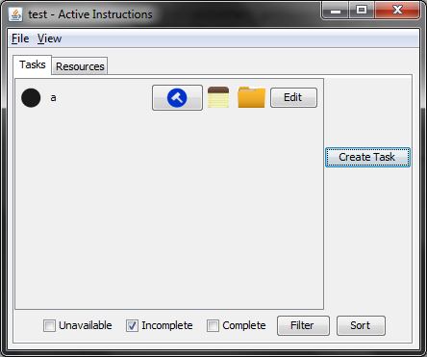

## Possible Buttons

|  |  |
| --- | --- |
|  | Working Button: Sets task to Working state. Will ask for Foreman & Builder upon click. If task hasn’t been started before, records start date. Starts/resumes recording working time. |
|  | Pause Button: Pause the current task. Sets task to Pause state. Stops recording working time. |
|  | Complete Button: Completes the current task. Requires password if not in Admin View. Records the finish date and stops recording working time. |
|  | Undo-complete Button: Undoes the Complete button. Will set the current task to the Paused state (if it can be worked on). Will not remove finish date. Only visible in Admin View. |

## Main States

|  |  |  |
| --- | --- | --- |
| C:\Users\Brian\GitHub\SAB-project-manager\src\res\unstarted.png | Unstarted | When a task is first created (assuming it can be worked on) it will begin in the Unstarted state. At this point, the task can only be changed to the Working state. |
| C:\Users\Brian\GitHub\SAB-project-manager\src\res\work.png | Working | The task is being worked on. It cannot be deleted or fully edited in this state. It can be changed to Pause or Completed states. It is recording the working time. |
| C:\Users\Brian\GitHub\SAB-project-manager\src\res\pause.png | Paused | The task has been worked on before, but is not currently being worked on. It can be changed to the Working state. It is not recording working time. |
| C:\Users\Brian\GitHub\SAB-project-manager\src\res\complete.png | Complete | The task is finished and will now open up other tasks that rely on this one. It can be changed to the Undo-completed state (See Undo-complete section below). |

## Unavailable States

|  |  |  |
| --- | --- | --- |
| C:\Users\Brian\GitHub\SAB-project-manager\src\res\unavailable.png | Unavailable | The task should be in the Unstarted state, but some task or resource dependency has not been met. |
| C:\Users\Brian\GitHub\SAB-project-manager\src\res\pause_bw.png | Unavailable Paused | The task should be in the Paused state, but some resource dependency has not been met. |
| C:\Users\Brian\GitHub\SAB-project-manager\src\res\unavailable_red.png | Unavailable w/ undo-completed dependencies | Like Unavailable except a task that this task depends on has been undo-completed. Mouse-over to see which task. |
| C:\Users\Brian\GitHub\SAB-project-manager\src\res\pause_red.png | Unavailable Paused w/ undo-completed dependencies | Like Unavailable Paused except a task that this task depends on has been undo-completed. Mouse-over to see which task. |
| C:\Users\Brian\GitHub\SAB-project-manager\src\res\complete_red.png | Complete w/ undo-completed dependencies | Like Complete except a task that this task depends on has been undo-completed. This task is still considered to be completed when checking whether other tasks are available. |

## Undo-completed States

When a task is undo-completed, all of its Status Icons will have a square shape instead of a circle shape. Otherwise, the meaning will be exactly the same.

## Broken Resources

When a resource is marked as broken, any affected tasks will have this icon: The task will also have its state set as if the resource is unavailable. Mouse-over the Broken Resource icon to see what broken resource this task needs.



## Filtering and Sorting Tasks

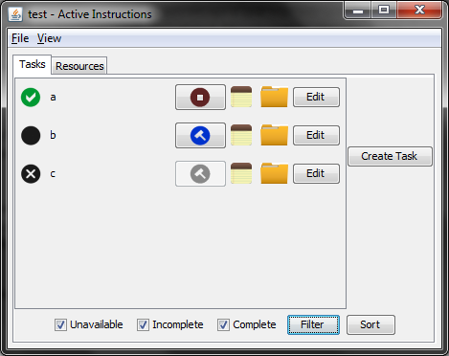

You can filter which tasks to display with the checkboxes and Filter button at the bottom of the Task panel. Clicking on the checkboxes alone will refresh what tasks are visible. If a task should be visible/invisible but is not, click on the Filter button to refresh the list.

Click on the Sort button to sort the tasks in the following order: Working, Paused, Unstarted, Complete, Unavailable Paused, and Unavailable.

# Task Notes

|  |  |
| --- | --- |
| C:\Users\Brian\GitHub\SAB-project-manager\src\res\notes.png | Click on the Notepad button to open a text box where you can write notes related to a task. These notes are persistent and can be viewed in this manner at any time. They will also be exported to the Excel sheet. |
| C:\Users\Brian\GitHub\SAB-project-manager\src\res\folder.png | Click on the Folder button to open the associated folder/file for this task. When clicked, a Windows Explorer window will be opened and have the particular file/folder selected |

# Exporting to Excel

To export, click on the Export menu item in the File menu. You will be asked for a location and name to save the file. Then Excel will be opened automatically so you can view the file.

TODO

# Normal Usage

# Opening and Saving a Project

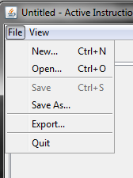

Use the Open menu item in the File menu to open a project. You must first enter the project folder and then open the project file inside (the file outlined in red below)

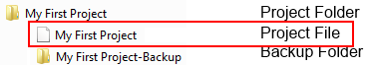

The program will save when you:

* Quit the program
* Open a new project
* Click the Save menu item (duh)

However, the program will NOT automatically save every period of time. Thus, hit Ctrl-S to save manually every once in a while to be safe.

# Task Status (Normal View)

This section deals with possible Task Statuses when in Normal View. At any point, mouse over a status icon or button to display a tooltip describing its meaning.

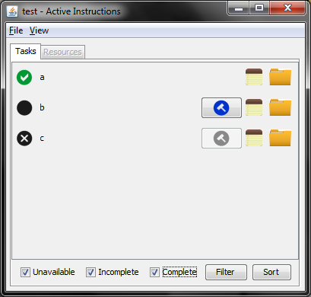

## Possible Buttons

|  |  |
| --- | --- |
|  | Working Button: Sets task to Working state. Will ask for Foreman & Builder upon click. If task hasn’t been started before, records start date. Starts/resumes recording working time. |
|  | Pause Button: Pause the current task. Sets task to Pause state. Stops recording working time. |
|  | Complete Button: Completes the current task. Requires password. Records the finish date and stops recording working time. |

## Main States

|  |  |  |
| --- | --- | --- |
| C:\Users\Brian\GitHub\SAB-project-manager\src\res\unstarted.png | Unstarted | When a task is first created (assuming it can be worked on) it will begin in the Unstarted state. At this point, the task can only be changed to the Working state. |
| C:\Users\Brian\GitHub\SAB-project-manager\src\res\work.png | Working | The task is being worked on. It cannot be deleted or fully edited in this state. It can be changed to Pause or Completed states. It is recording the working time. |
| C:\Users\Brian\GitHub\SAB-project-manager\src\res\pause.png | Paused | The task has been worked on before, but is not currently being worked on. It can be changed to the Working state. It is not recording working time. |
| C:\Users\Brian\GitHub\SAB-project-manager\src\res\complete.png | Complete | The task is finished and will now open up other tasks that rely on this one. It can be changed to the Undo-completed state (See Undo-complete section below). |

## Unavailable States

|  |  |  |
| --- | --- | --- |
| C:\Users\Brian\GitHub\SAB-project-manager\src\res\unavailable.png | Unavailable | The task should be in the Unstarted state, but some task or resource dependency has not been met. |
| C:\Users\Brian\GitHub\SAB-project-manager\src\res\pause_bw.png | Unavailable Paused | The task should be in the Paused state, but some resource dependency has not been met. |
| C:\Users\Brian\GitHub\SAB-project-manager\src\res\unavailable_red.png | Unavailable w/ undo-completed dependencies | Like Unavailable except a task that this task depends on has been undo-completed. Mouse-over to see which task. |
| C:\Users\Brian\GitHub\SAB-project-manager\src\res\pause_red.png | Unavailable Paused w/ undo-completed dependencies | Like Unavailable Paused except a task that this task depends on has been undo-completed. Mouse-over to see which task. |
| C:\Users\Brian\GitHub\SAB-project-manager\src\res\complete_red.png | Complete w/ undo-completed dependencies | Like Complete except a task that this task depends on has been undo-completed. This task is still considered to be completed when checking whether other tasks are available. |

## Undo-completed States

When a task is undo-completed, all of its Status Icons will have a square shape instead of a circle shape. Otherwise, the meaning will be exactly the same.

## Broken Resources

When a resource is marked as broken, any affected tasks will have this icon: C:\Users\Brian\GitHub\SAB-project-manager\src\res\broken_part.png The task will also have its state set as if the resource is unavailable. Mouse-over the Broken Resource icon to see what broken resource this task needs.

## Filtering and Sorting Tasks



You can filter which tasks to display with the checkboxes and Filter button at the bottom of the Task panel. Clicking on the checkboxes alone will refresh what tasks are visible. If a task should be visible/invisible but is not, click on the Filter button to refresh the list.

Click on the Sort button to sort the tasks in the following order: Working, Paused, Unstarted, Complete, Unavailable Paused, and Unavailable.

# Task Notes

|  |  |
| --- | --- |
| C:\Users\Brian\GitHub\SAB-project-manager\src\res\notes.png | Click on the Notepad button to open a text box where you can write notes related to a task. These notes are persistent and can be viewed in this manner at any time. They will also be exported to the Excel sheet. |
| C:\Users\Brian\GitHub\SAB-project-manager\src\res\folder.png | Click on the Folder button to open the associated folder/file for this task. When clicked, a Windows Explorer window will be opened and have the particular file/folder selected |